INDEX
Sr. No. | Content | Page No.
1 | CHAPTER 1 : INTRODUCTION
 | 1.1 Company Profile
 | 1.2 Introduction
 | 1.3 Existing System
2 | CHAPTER 2 : PROPOSED SYSTEM
 | 2.1 Problem statement
 | 2.2 Product position statement
 | 2.3 Product overview
 | 2.4 Summary of capabilities
 | 2.5 Assumptions and dependencies
 | 2.6 Objectives of proposed system
 | 2.7 Functional requirements
 | 2.8 Nonfunctional requirements
 | 2.9 Stakeholder summary
 | 2.10 Users summary
 | 2.11 Module specifications
 | 2.12 Operating environment
3 | CHAPTER 3 : REQUIREMENT DETERMINATION AND ANALYSIS
 | 3.1 Fact finding method
 | 3.2 Feasibility study
4 | CHAPTER 4 : SYSTEM ANALYSIS & DESIGN
 | 4.1 Use Case Diagrams
 | 4.2 Activity Diagram/ERD
 | 4.3 Sequence Diagram
 | 4.4 Component Diagram
 | 4.5 Deployment & Component Diagram
 | 4.6Class Diagram
 | 4.7 Object Diagram
 | 4.8 State Chart Diagram
 | 4.9 User Interface Design
 | 4.10 Table Specifications
 | 4.11 Test Procedures & Implementation
5 | CHAPTER 5: USER MANUAL
 | 5.1 User Manual
 | Drawback and Limitation
 | Proposed Enhancement
 | Conclusion
 | Bibliography

COMPANY PROFILE
Name of the company : Pawar Software Solution Pvt. Ltd.
- Company Profile
- Pawar Software Solution Pvt. Ltd is a leading global technology services provider, delivering business solutions to its customers. Pawar Software Solution Pvt. Ltd founded the information technology service provider industry more than 2 years ago. Today, as an Internet Solution Provider, Apps Techno delivers one of the industry’s broadest portfolios of information technology services to customers in the education, manufacturing, financial services, healthcare, communications, energy, transportation, and consumer and retail industries, and to governments around the world. We have developed several software ranges and today, we are taking new paths, like ERP Module, complete web and Internet promotions, SMS API Solution Consultant and many new top features.
- What we offer
- As our customers’ trusted business, we provide the best solutions for executives to maximize return on their IT investments. Our deep industry knowledge enables us to provide innovative ideas that help to improve productivity and security. We deliver on our commitments, so customers can build strong relationships with us, achieve profitable growth and win in the marketplace.
- What team consists?
- Pawar Software Solution Pvt. Ltd has more than 25+ people serving 45+ clients in India. Pawar Software Solution Pvt. Ltd recognizes that its most important asset and success factor is its employees. We value the different skills, backgrounds, experiences and perspectives throughout our global community and acknowledge these qualities as a competitive differentiator in the marketplace. Our Company teams help clients meet complex business challenges. Pawar Software Solution Pvt. Ltd team grows ahead with Innovation, Technology blend and analytical skills.

- Business Experience
- Pawar Software Solution Pvt. Ltd has over 2 years’ experience in providing professional web application services and solutions for clients across the globe. We have successfully implemented forty five projects of different sizes and complexity in various business and technology domains.
- Technology Competence
- Our unique competence in various technologies enables us to deliver integrated, scalable, robust solutions with the optimal cost/performance ratio. Our team experts constantly conduct research on new technology products to meet the ever-growing customer needs.
- Commitment to Quality
- While retaining competitive rates we never compromise the quality of our services. We closely monitor project activities at all development phases and guarantees defect prevention, project risk mitigation and high quality results.
- Our Area of Expertise
- Web Design
- Web Page Layout Design
- GUI Component Design
- Flash movies / Animation / Intro Flash
- Web Cast & Video Streaming
- Action Scripts
- E-Brochure Design
- CSS / XSL Implementation
- Website Audit & Maintenance

- Programming Environment and Scripting Language
- Java | JSP
- PHP | PHP3
- JSON | JQUERY
- Angular JS | Node JS
- AJAX | HTML5 |CSS3
- ANDROID | IOS
- Python

Project Introduction

Computer is the backbone of today’s industry and plays a vital role in its development. Now a day each industry prefers the computerized version of their existing system that helps themselves to be with challenging and rapidly growing industry. It also provides the features of expansion and development of the system.

The proposed system is for “Company Billing”. As present this system is not computerized. The need for computerization is in order to do overcome the hard work done manually and to do it easily & fastly than old system.
. It also provides the features of expansion and development of the system.
This Company Billing system can be used by only admin and users of system They can handle the all product information and billing details for history data. Which save the times for billing calculation and more business works. Main objective build the system this is to provide maintain the product data to the customer. Each menu item has a name, price and associated code for search the product easily. This application helps to track the particular bills and modify it.
It has functionality to save and print the bills.

In summary, this report represents my dedicated efforts in computerizing the system of my best level.

Existing System
Existing System is very complex when it comes to GST billing because this billing very critical task to complete.
The overall system is designed to be a menu driven and user-friendly, so that an average person having familiar with ABC only, will also be able to operate the system efficiently.
We have tried to eliminate all possible errors and disadvantage in manual system.
Few of the advantage are pointed out.
- Accuracy
Major drawback of manual work is that while performing load may cause such type of errors. The Computer once programmed properly will never raise such type of error. So, Accuracy is major constraint which should be the achieved up to maximum level.
- Time Saving

As the manual System requires the same data to be repeatedly written in each bill, it is time consuming also the manual calculate take a lot of time.
The updating facility updates the master data.
- Man Power Utilization

In manual system a lot of manual power is engaged in the overall process where as in proposed system it will require only two people to operate the system. This makes available a lot of manpower, which can be use in other work

Scope

This System Is mainly designed for manufacturing company to keep the track of all billing & delivery challan information. Scope of this project is to investigate and design a software solution which can facilitate both customer and sales person in performing their daily tasks, improving efficiency, and helping them to be more productive. This project will provide a solution through which salesperson can easily manage, handle and generate all required information in their respective format when needed. This system covers stock control, management and tends to correct anomalies in business. It analysis adding of new item, generate bill with GST and ability to view existing ones. It provides quick way of operation by capturing the manual process and automating them. It will help them to manage new item details, financial data, and historical data and also in producing bill of GST formats for different customers. This solution will help salesperson in reducing effort spend on managing orders. It will also provide them opportunity to explore possibility of generating documents, managing financial details.

DETAILS DESCRIPTION OF TECHNOLOGY USED
HTML
HTML is the standard markup language for creating Web pages.
- HTML stands for Hyper Text Markup Language
- HTML describes the structure of Web pages using markup
- HTML elements are the building blocks of HTML pages
- HTML elements are represented by tags
- HTML tags label pieces of content such as "heading", "paragraph", "table", and so on
- Browsers do not display the HTML tags, but use them to render the content of the page
- The <!DOCTYPE html> declaration defines this document to be HTML5
- The <html> element is the root element of an HTML page
- The <head> element contains meta information about the document
- The <title> element specifies a title for the document
- The <body> element contains the visible page content
- The <h1> element defines a large heading
- The <p> element defines a paragraph
SQL
SQL is a standard language for accessing and manipulating databases.

What is SQL?
- SQL stands for Structured Query Language
- SQL lets you access and manipulate databases
- SQL is an ANSI (American National Standards Institute) standard

What Can SQL do?
- SQL can execute queries against a database
- SQL can retrieve data from a database
- SQL can insert records in a database
- SQL can update records in a database
- SQL can delete records from a database
- SQL can create new databases
- SQL can create new tables in a database
- SQL can create stored procedures in a database
- SQL can create views in a database
- SQL can set permissions on tables, procedures, and views

SQL is a Standard - BUT....
Although SQL is an ANSI (American National Standards Institute) standard, there are different versions of the SQL language.
However, to be compliant with the ANSI standard, they all support at least the major commands (such as SELECT, UPDATE, DELETE, INSERT, WHERE) in a similar manner.
Note: Most of the SQL database programs also have their own proprietary extensions in addition to the SQL standard!

Using SQL in Your Web Site
To build a web site that shows data from a database, you will need:
- An RDBMS database program (i.e. MS Access, SQL Server, MySQL)
- To use a server-side scripting language, like PHP or ASP
- To use SQL to get the data you want
- To use HTML / CSS to style the page

CSS
CSS stands for Cascading Style Sheets.
CSS describes how HTML elements are to be displayed on screen, paper, or in other media.
CSS saves a lot of work. It can control the layout of multiple web pages all at once.
CSS can be added to HTML elements in 3 ways:
- Inline - by using the style attribute in HTML elements
- Internal - by using a <style> element in the <head> section
- External - by using an external CSS file
The most common way to add CSS, is to keep the styles in separate CSS files. However, here we will use inline and internal styling, because this is easier to demonstrate, and easier for you to try it yourself.

Bootstrap
- Bootstrap is a free front-end framework for faster and easier web development
- Bootstrap includes HTML and CSS based design templates for typography, forms, buttons, tables, navigation, modals, image carousels and many other, as well as optional JavaScript plugins
- Bootstrap also gives you the ability to easily create responsive designs

Why Use Bootstrap?
Advantages of Bootstrap:
- Easy to use: Anybody with just basic knowledge of HTML and CSS can start using Bootstrap
- Responsive features: Bootstrap's responsive CSS adjusts to phones, tablets, and desktops
- Mobile-first approach: In Bootstrap 3, mobile-first styles are part of the core framework
- Browser compatibility: Bootstrap is compatible with all modern browsers (Chrome, Firefox, Internet Explorer, Safari, and Opera)

PHP
- PHP, which stands for Hypertext Preprocessor, is a popular server-side scripting language designed specifically for web development.
- PHP is open-source, free to use, and runs on most web servers.
- It can be embedded into HTML, and it is often used to create dynamic web pages or applications that interact with databases.
- PHP code is executed on the server before the resulting HTML is sent to the client's web browser. PHP code can be used for a variety of purposes, including creating dynamic content, handling form data, sending and receiving cookies, interacting with databases, and more. PHP is a popular language for web development because it is easy to learn, widely used, and well-supported by a large community of developers.

PROPOSED SYSTEM
2.1 Problem Statement
The manual system is very complex to be managed and searching or updating the information. The main problem is to manage Billing data for Company. & it’s very hard to manage copy of each GST Bills. To get Outstanding of particular Company need to check complete bills.

2.2 Product position statement
Our cloud-based GST billing system is designed to streamline the invoicing process for small and medium-sized businesses. With its user-friendly interface and robust features, our system simplifies the complex GST billing process while ensuring compliance with all applicable regulations.
Our system offers a range of features, including automated invoicing, real-time tracking of expenses and revenue, and integration with popular accounting software. With built-in reporting tools, businesses can quickly generate detailed reports on their financials, making it easier to make informed decisions and plan for the future.
Our cloud-based system offers the added advantage of accessibility from anywhere, at any time, allowing users to easily manage their invoicing needs on-the-go. With industry-leading security measures in place, businesses can rest assured that their sensitive financial information is safe and protected.
Overall, our cloud-based GST billing system provides a comprehensive and reliable solution for businesses looking to simplify their invoicing process, improve their financial management, and ensure compliance with GST regulations.

2.3 Product overview
The Cloud GST Billing System is an online billing software designed to streamline and simplify the invoicing process for businesses of all sizes. The system automates and centralizes billing processes, allowing businesses to generate GST-compliant invoices quickly and easily. The software is cloud-based, which means that it can be accessed from anywhere with an internet connection, making it ideal for businesses with multiple locations or remote teams.
The system includes a user-friendly interface that can be easily customized to suit the needs of the business. Features include customer management, product management, invoice generation, payment tracking, and inventory management. The system also includes reporting and analytics tools that provide businesses with valuable insights into their billing and sales performance.
The Cloud GST Billing System is designed to be scalable and flexible, allowing businesses to add or remove features as their needs change. The system is also fully compliant with GST regulations and can generate GST invoices with ease. The software is regularly updated with the latest GST rules and regulations, ensuring that businesses remain compliant at all times.
Overall, the Cloud GST Billing System is an essential tool for any business that needs to generate invoices quickly and efficiently while remaining GST-compliant. The system's cloud-based design, scalability, flexibility, and compliance features make it an ideal solution for businesses of all sizes.

2.4 Summary of capabilities
The cloud GST billing system has several capabilities that make it a comprehensive solution for businesses of all sizes. Some of the key capabilities are:
- Customer Management: Allows the user to manage customer information, including names, contact details, addresses, and payment information.
- Transaction Management: Enables the user to create and manage transactions such as purchases, sales, refunds, and returns.
- Debit Note Management: Allows the user to generate debit notes for adjustments to invoices, such as a reduction in price or quantity.
- Credit Note Management: Enables the user to create credit notes for adjustments to invoices, such as a refund or credit issued to a customer.
- User Management: Allows the administrator to manage user accounts and assign permissions for different roles and tasks.
- Challan Management: Enables the user to create and manage challans for goods transportation, including generating E-way bills.
- Product Management: Allows the user to manage product information, including product names, descriptions, prices, and taxes.
- Invoice/Bill Management: Enables the user to generate and manage bills/invoices, including generating invoices for different tax types (CGST, SGST, IGST).
- Reporting: Provides the user with a range of reports related to billing, transactions, inventory, taxes, and more, which can be exported to different file formats.
- Settings: Allows the user to configure various settings related to billing, taxes, users, and more, such as adding tax rates, creating new user accounts, and setting up notifications.
Overall, the cloud GST billing system is a comprehensive solution that can help businesses streamline their GST compliance and financial management processes.

2.5 Assumptions and dependencies
Assumptions:
- The user has a stable and fast internet connection.
- The user has basic knowledge of billing systems and GST regulations.
- The user has a computer or device with a modern web browser that supports HTML5 and CSS3.
Dependencies:
- The system requires a cloud server to host the web application.
- The system depends on third-party APIs to fetch currency exchange rates and tax rates.
- The system depends on a secure database to store customer data, transaction data, and user data.
- The system relies on reliable payment gateways to process online transactions
2.6 Objectives of proposed system
The main objective of the Proposed System is to Computerize the functioning easily and comfortably to interact with computerized system with efficient Management Control.

The advantages of the Proposed System are as follows………..
  - Reduces human-efforts.
  - Its Very easy to create bills and keep track or bills.
  - Easy to create challan.
  - Maintain each transaction details of payment.
  - Ability to generate outstanding reports.
  - Ability to store and print bill directly.
  - Its store bills in various Format. Many options to export data.
  - Accuracy and Quality Report can be achieved.
- 2.7 Functional requirements
- Manage Customers: The system should allow creating, updating, and deleting customer information. It should also provide the ability to search and view customer details.
- Manage Transactions: The system should support creating, editing, and deleting transactions, including invoicing and payment processing. It should also provide the ability to view transaction history and details.
- Manage Debit Note: The system should allow creating, updating, and deleting debit note related to transactions.
- Manage Credit Note: The system should allow creating, updating, and deleting credit note related to transactions.
- Manage Users: The system should provide user management functionalities, such as creating, updating, and deleting user accounts, assigning user roles and permissions.
- Manage Challan: The system should support creating and managing challans, including the ability to generate challan reports.
- Manage Products: The system should provide functionalities for adding, editing, and deleting product information, including product descriptions, prices, and tax rates.
- Manage Bills/Invoices: The system should allow generating bills/invoices based on the transactions, with the ability to customize the bill format and details.
- Reports: The system should provide various reports, such as sales reports, customer reports, transaction reports, and tax reports.
- Settings: The system should allow configuring various settings, such as tax rates, payment methods, and system preferences.
These are some of the primary functional requirements for a cloud GST billing system.

2.8 Non-functional requirements
- Performance: The system should be able to handle a large number of users and transactions efficiently, without any lag or delays.
- Security: The system should provide secure access and protect sensitive information such as user credentials, financial data, and personal information from unauthorized access, hacking, or data breaches.
- Scalability: The system should be able to scale up or down based on the changing business requirements and handle peak loads without any performance degradation.
- Availability: The system should be available 24/7 without any downtime, and should have a disaster recovery plan in place to ensure business continuity in case of any disasters or system failures.
- Usability: The system should have a user-friendly interface that is easy to use, navigate, and understand by users of different skill levels.
- Compatibility: The system should be compatible with different operating systems, browsers, and devices, to ensure accessibility and ease of use.
- Maintainability: The system should be easy to maintain, update, and upgrade without any disruption to the business operations.
- Compliance: The system should comply with the relevant regulatory and compliance requirements related to data privacy, security, and financial transaction.

2.9 Stakeholder summary

- Business Owners: The business owners are the primary stakeholders in the system. They will use the system to manage their business operations, including invoicing, financial reporting, and compliance with GST regulations.
- Customers: Customers will use the system to receive invoices and make payments for the products or services they purchase from the business.
- Accountants: Accountants may use the system to review financial reports and ensure that the business is compliant with GST regulations.
- IT Team: The IT team will be responsible for the implementation and maintenance of the system, ensuring that it is secure, reliable, and scalable.
- Government Tax Authorities: Government tax authorities will use the system to verify the accuracy of the GST returns filed by the business, and to ensure compliance with GST regulations.
- Third-party Service Providers: Third-party service providers may use the system to provide services such as payment processing, accounting software integration, and data analytics.

2.10 Users summary
Admin: The admin is responsible for managing the system, adding new users, managing user permissions, and overseeing the overall operation of the system.

2.11 Module specifications
1.Admin Module
This Module Manage All profile of customer and their billing data. Users in this module have complete functionality of the application. Where they can access reports or other data .
This user can create multiple account with add, edit, delete, access in system.
2. Excel Module
This Module create Bills and Challan In to Different Format & Data. This Module Not create excel file every time create is created. This module is create excel file when is required by user.
3 Access Management
This module manage all access of admin & staff and other users of the system.
This Module restrict the functionality for unauthorized user and show the proper error sms.
This module manage access of the users through of the system.
4. Encryption management
This Module maintain the security of all pages and access. This module provide encryption method to hide main data. This function provide encrypted key to store password, contact.
5. validation module
This Module handle all form validation thought the application. And Maintain the missing pages access to user. And redirect to correct direct. This validation all the forms in the application.
6.Report Management
This Application generate report for admin that includes the reports in graphical view. Includes
Total Outstanding Of Company.
Total Paid Amount.
Total Debit Amount.
Total Payment Expected.

2.12 Operating Environment
HARDWARE REQUIREMENT
- 1.8 Hz processor.
- 4GB SD-RAM
- 4 GB Hard-Disk.
SOFTWARE REQUIREMENT
- Front End – HTML, CSS, Bootstrap, JQuery, Ajax .
- Back End – JSP,PHP, MySQL
- Server – Apache Server 2.0
- Design Tool – Macromedia Dreamweaver 12.0
- Documentation Tools – Microsoft Word

Web Requirements
- Bandwidth – 1mbps(minimum)
- Internet – 512 kbps(minimum)
- Internet Explorer 8.0 or any browser

REQUIREMENT DETERMINATION AND ANALYSIS
3.1 Fact finding methods

To study the system we need to collect facts.
The specific methods used for collecting data are called fact finding techniques. Different fact finding techniques are:
- Interview Technique
- Record Review technique
- Observation Technique

- Interviews-> Analyst uses interviews to collect information from individual or from groups. The interview is the best method for producing the qualitative information

- Questionnaire->Questionnaires allows analyst to collect information about various aspects of the system from large number of persons. The use of the standardized question format can produce mare reliable data than other fact finding techniques.

- Record Review-> Many kinds of records & reports can provide valuable information about organization and its operation. In record reviews, analyst examines the information that has been recorded about the system and about the users. Also much of the information is gathered by reviewing the past & original documents, which give clear format style & recording.

- Observation->through the observation, analyst can obtain the first hand information about how activities are carried out. This method is most useful when the analyst need to be actually observe how documents are handled, how processes are carried out, whether specified steps are actually followed or not. When I went to company I observed the each & every process which is going on there. I got very important information as well as I understand the current system very well. I observed that the flow of registration at the system very well. We observed that
- What kind of system?
- What does it do?
- Who run the system?
- Who are the important people in it?
- What is the history of the system?
3.2 Feasibility Study
- Technical Feasibility
- Economical Feasibility
- Operational Feasibility

- Technical Feasibility:-
Proposed system is very much technically feasible because it can be developed using existing software and hardware. This evaluation determines whether the technology needed for the proposed system is available or not.
The software’s required to build, maintain and upgrade the system are available for free. Open source package such as Android and java can be combined to make the system more cost effective. In addition, due to the easy availability of such software’s the system is Technically Feasible.

- Economic Feasibility:-

The cost overhead include software and hardware maintenance cost, operating cost and includes cost required for man power, electricity etc. The proposed system will provide the right type of the information at right time, and in the required format.
This feasibility checks whether the system can be developed with the available funds. With the use of open source software the maintenance cost can be brought down to zero. Hence a lot of money is saved to provide economical feasibility. The total cost of developing, maintaining and using this system is meager. Hence this system is economically feasible.
This will save time required for accessing information and routine operation, which will result in business growth. Consisting all these advantage, the cost overheads of the system are negligible.

- Operational Feasibility:-

The proposed system is easy to use, so the user will operate this application. This application is user friendly. It will work on Android mobile, Android tab also. It will work on internet therefore it access the data. It therefore the system is operationally feasible as it is very easy for end users to operate it.

System Analysis and System Design

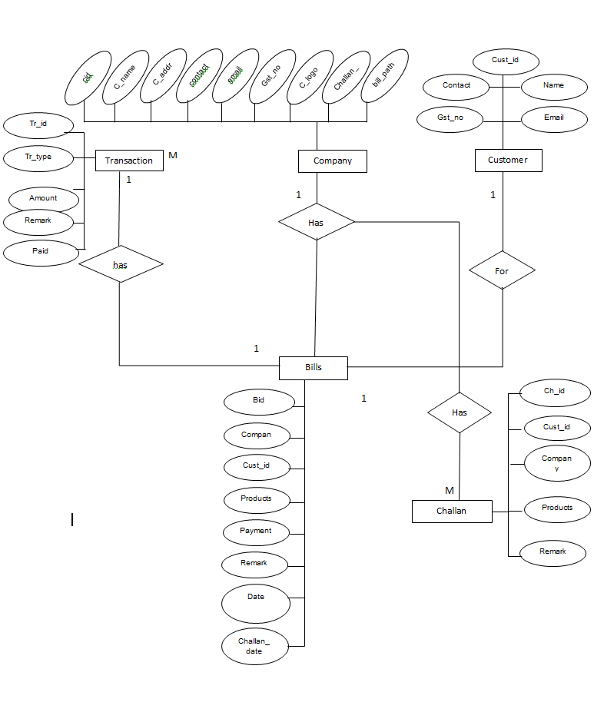ER Diagram

Class Diagram
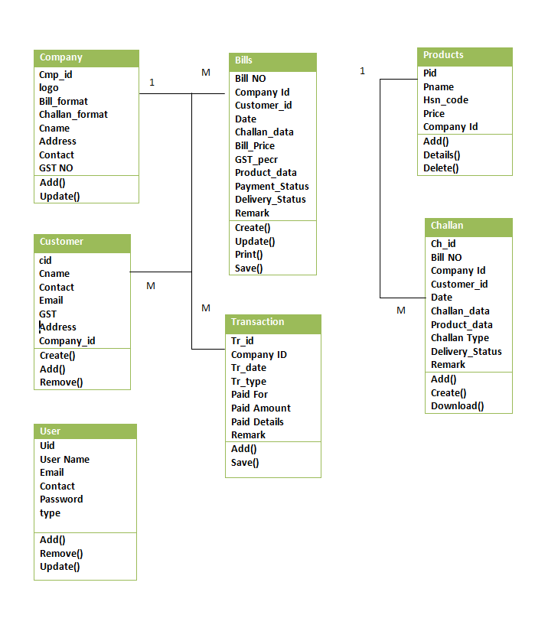

Object Diagram
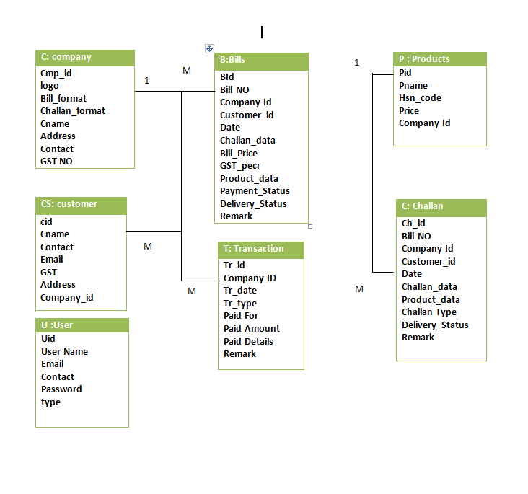

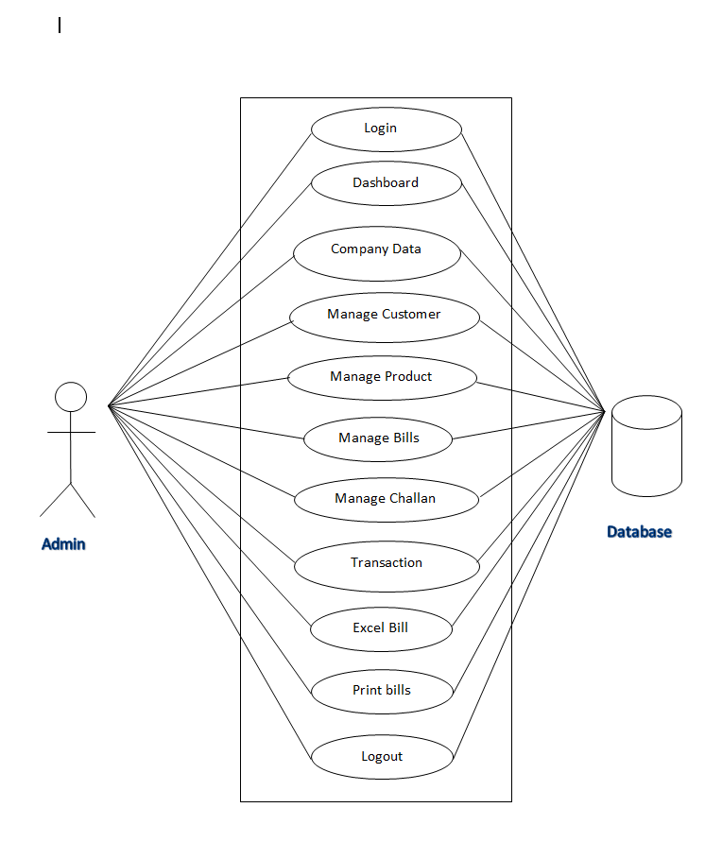Use case diagram

Sequence Diagram
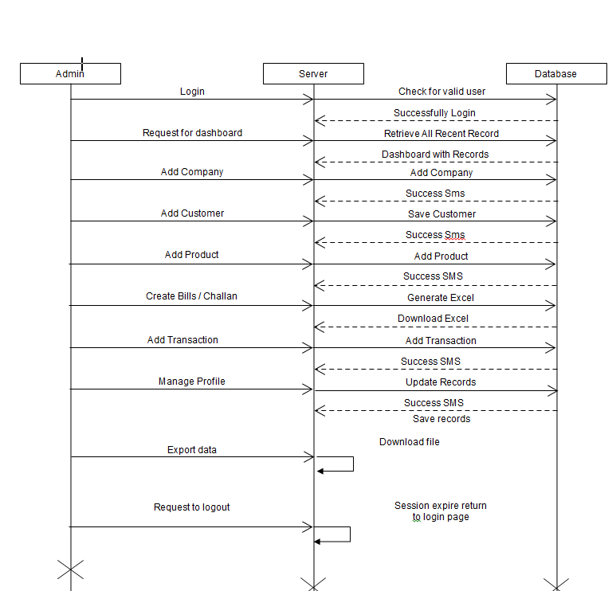

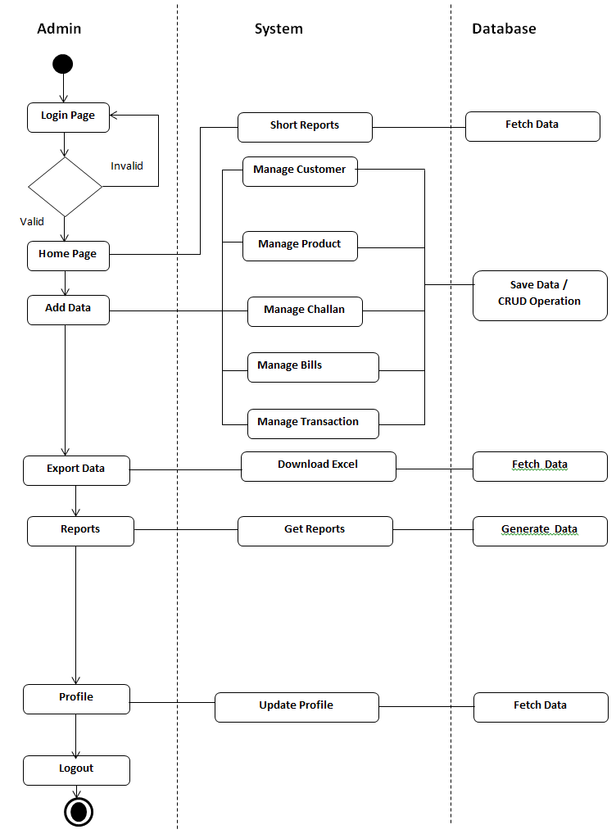Activity Diagram

Component
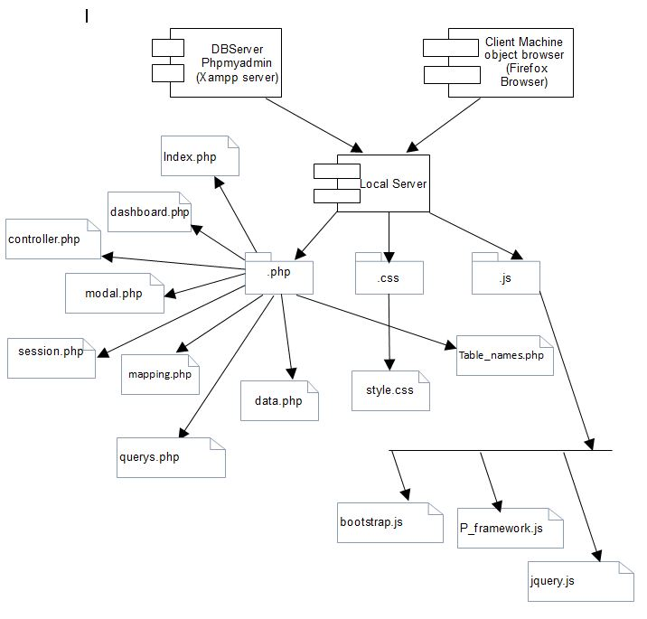

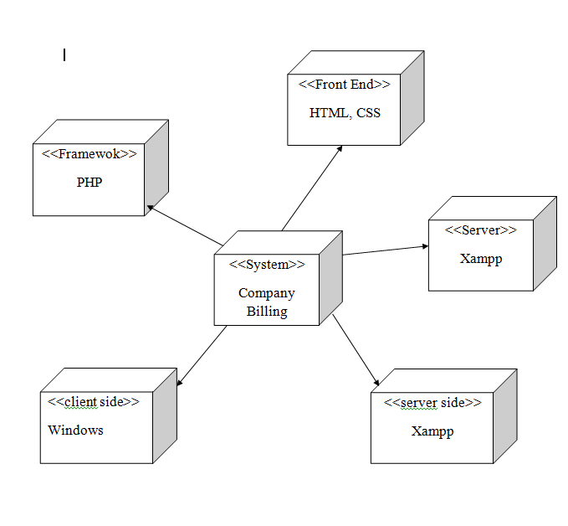Deployment

Screen Shots
Dashboard

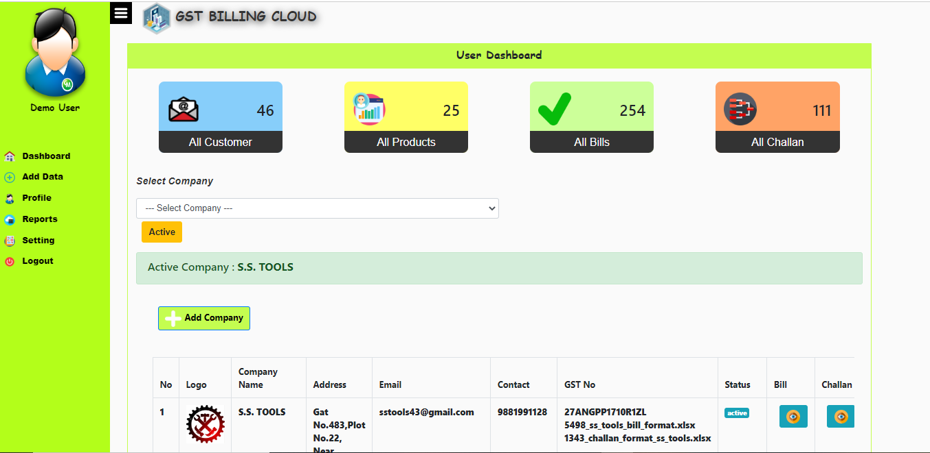

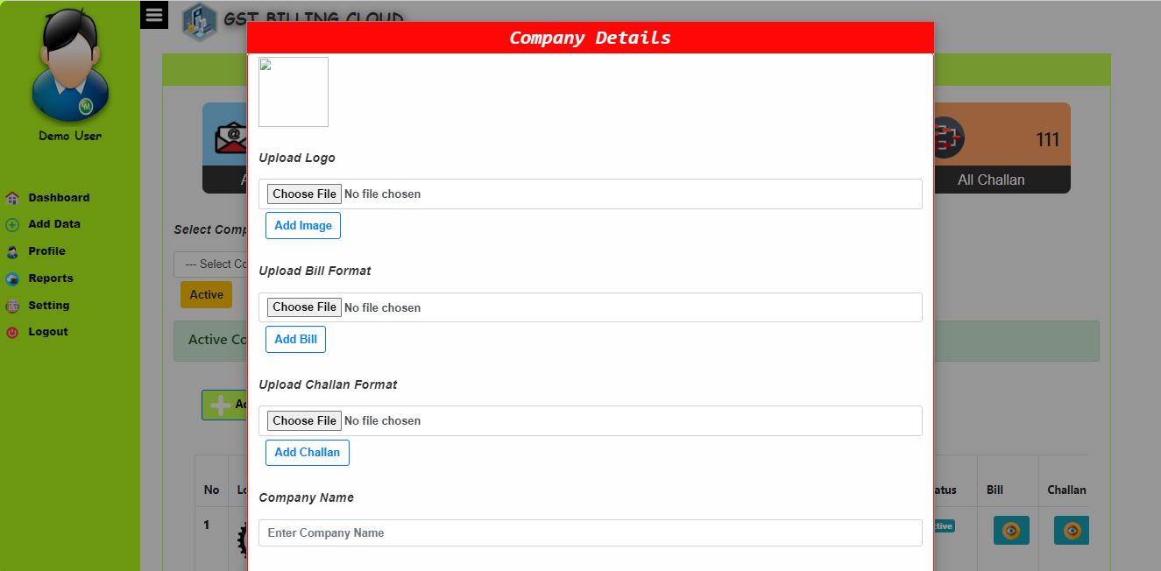

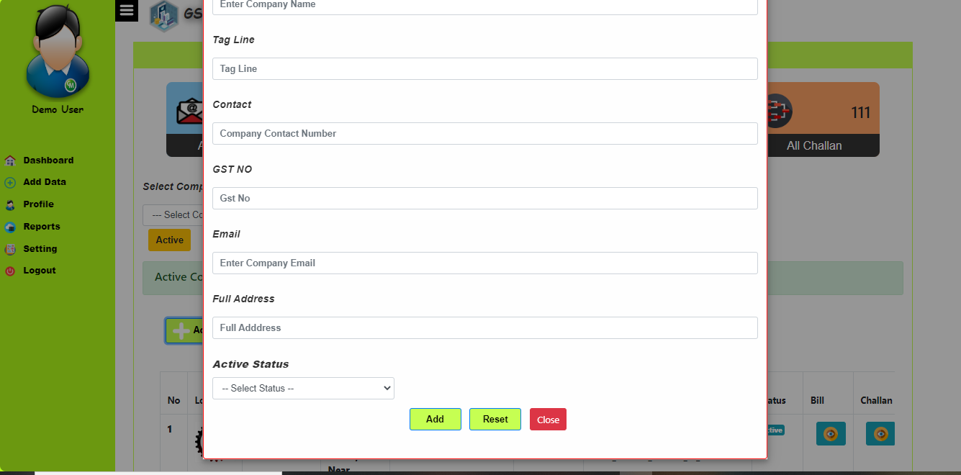

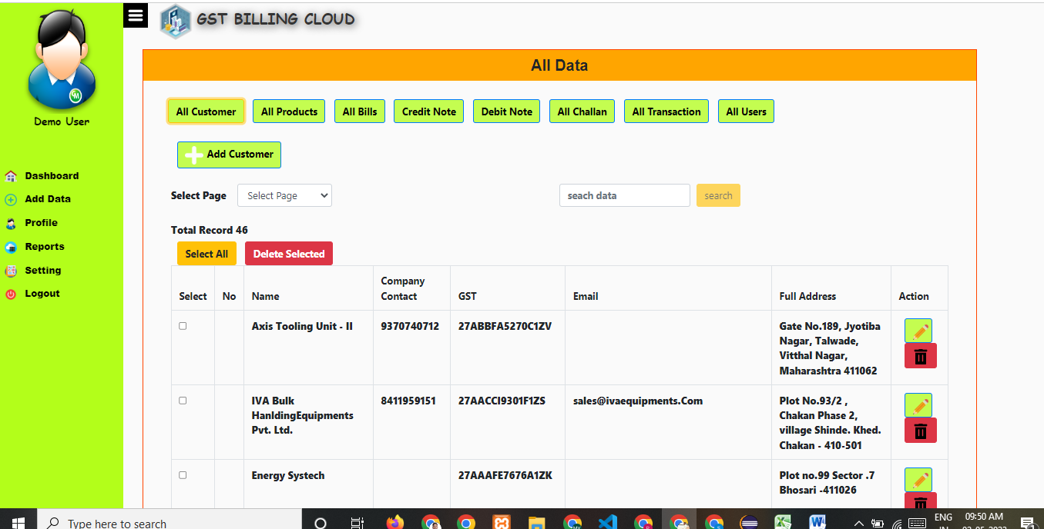
All Customer

Add Customer
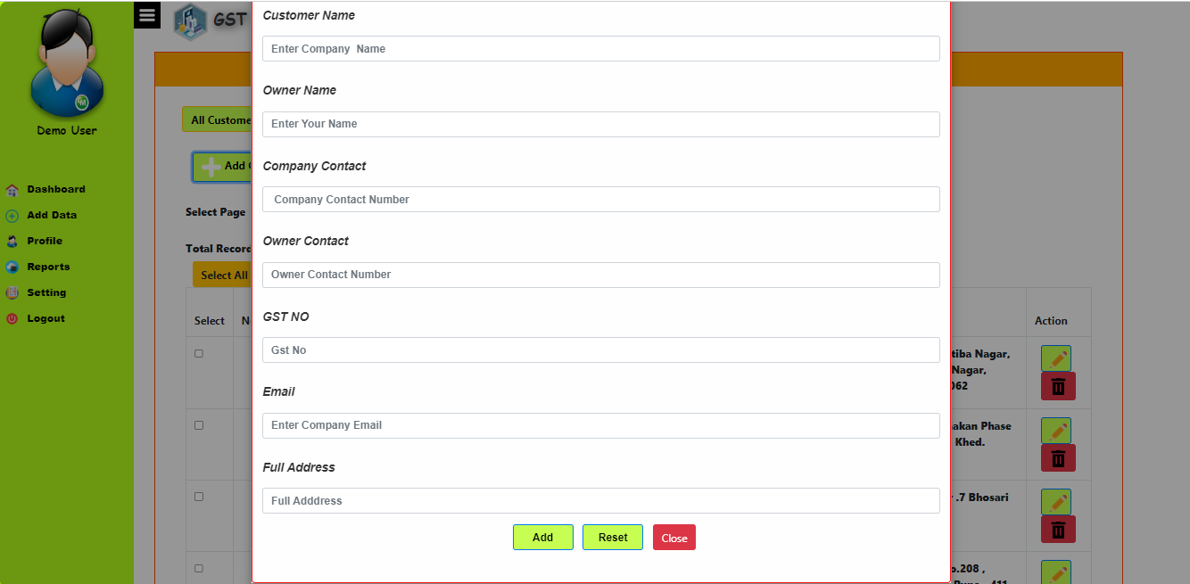

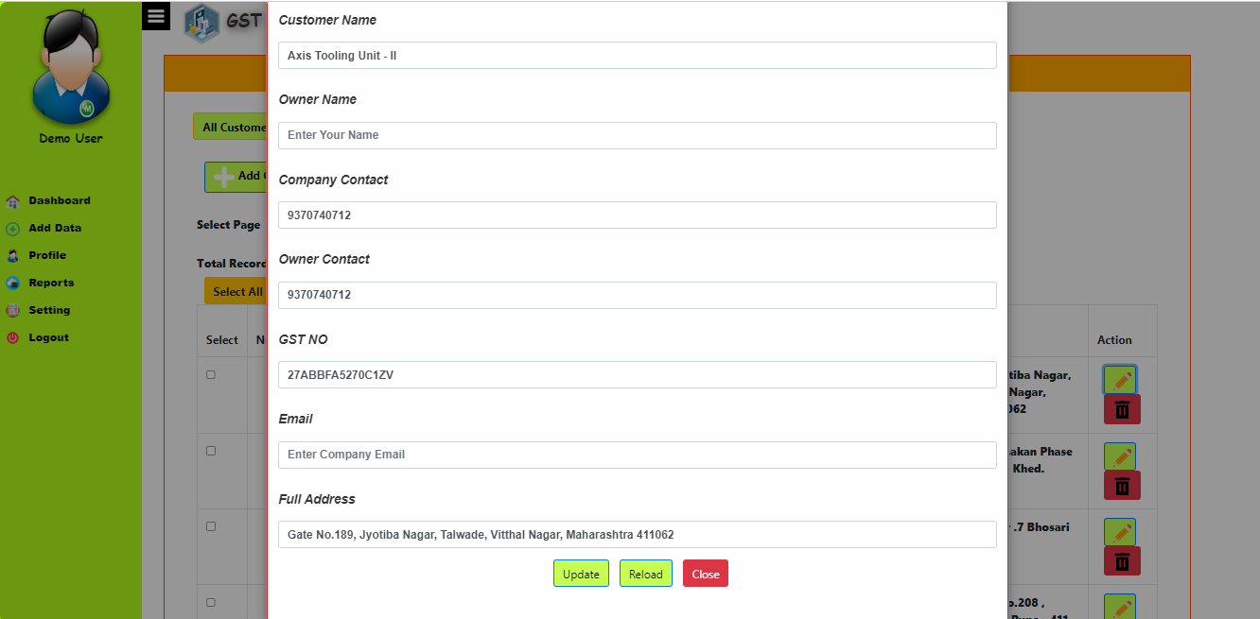
Edit Customer

All Product
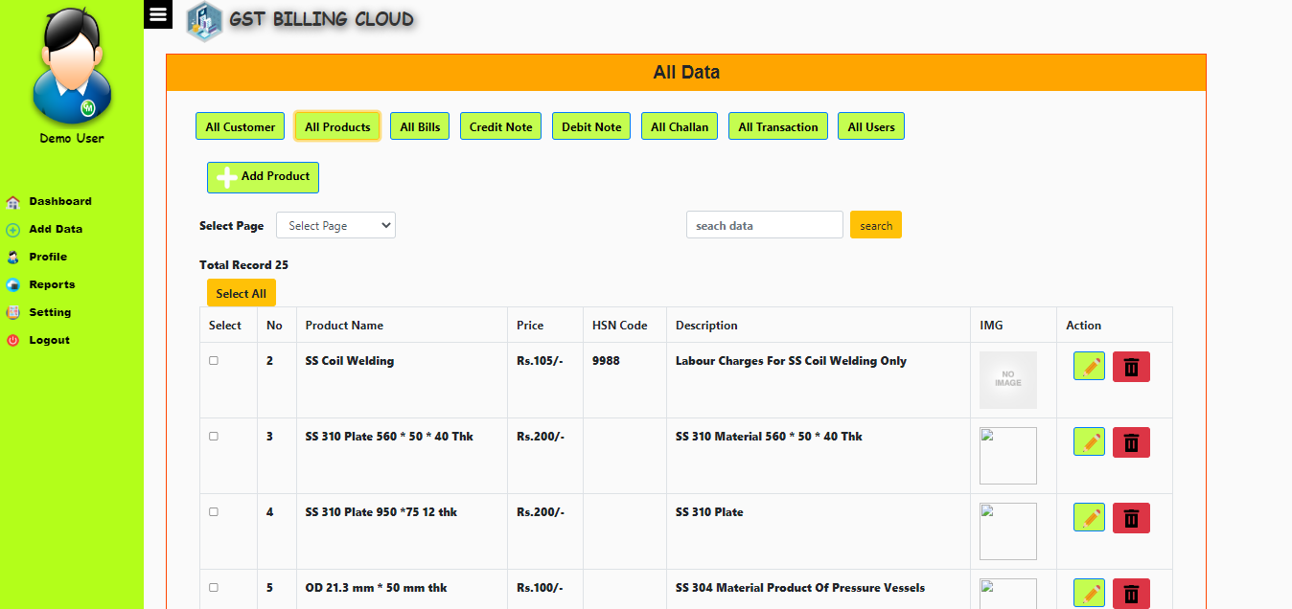

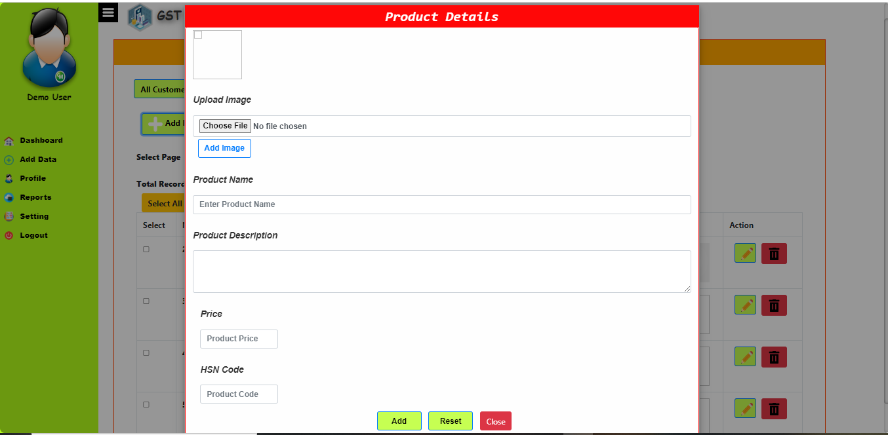
Add Product

GST List
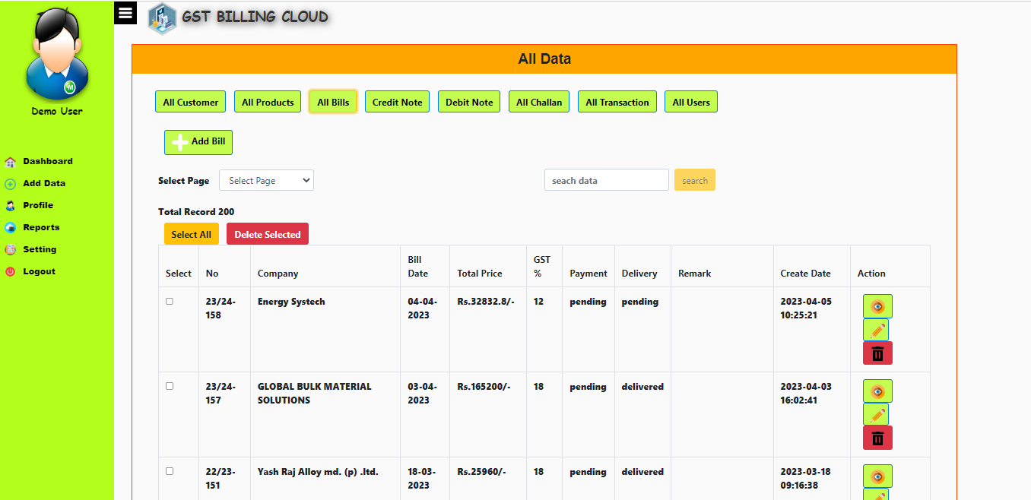

Add Invoice
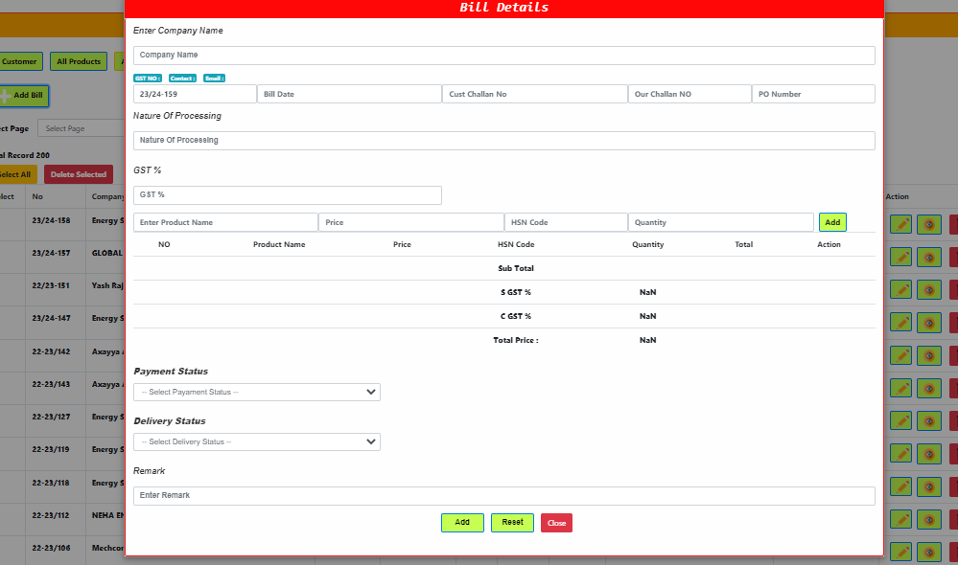

Edit Invoice
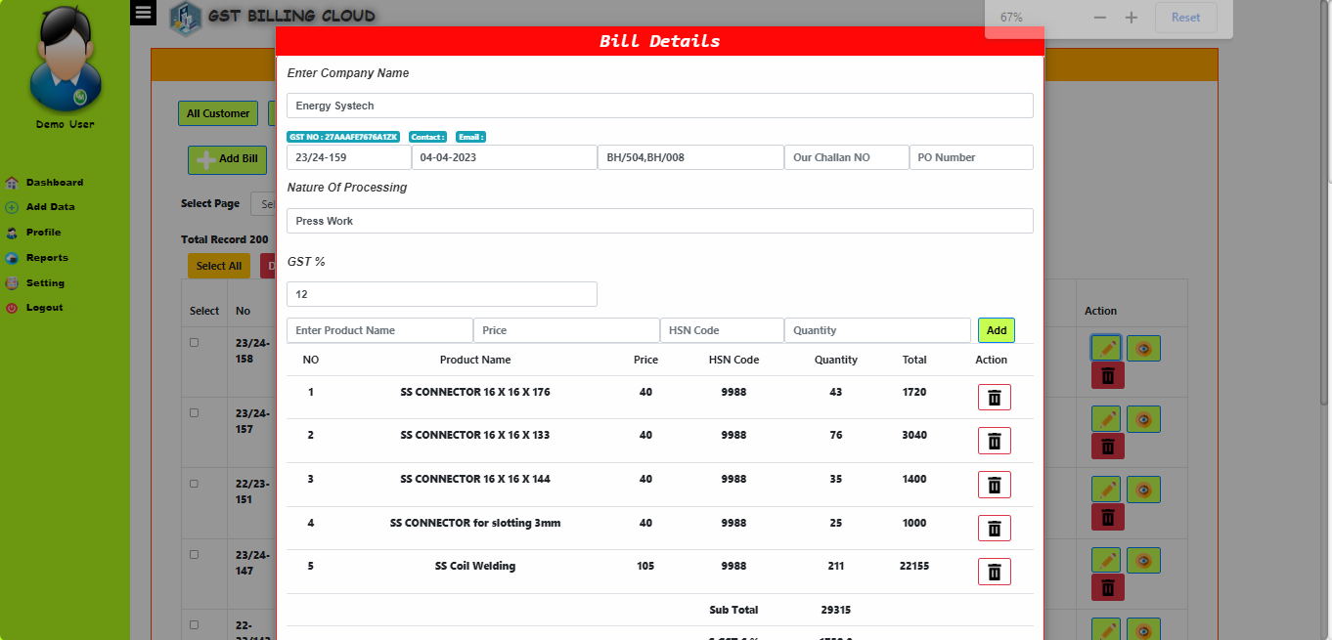

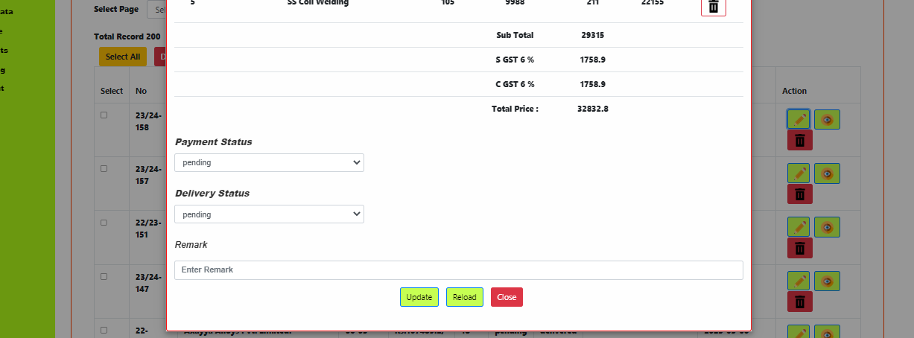

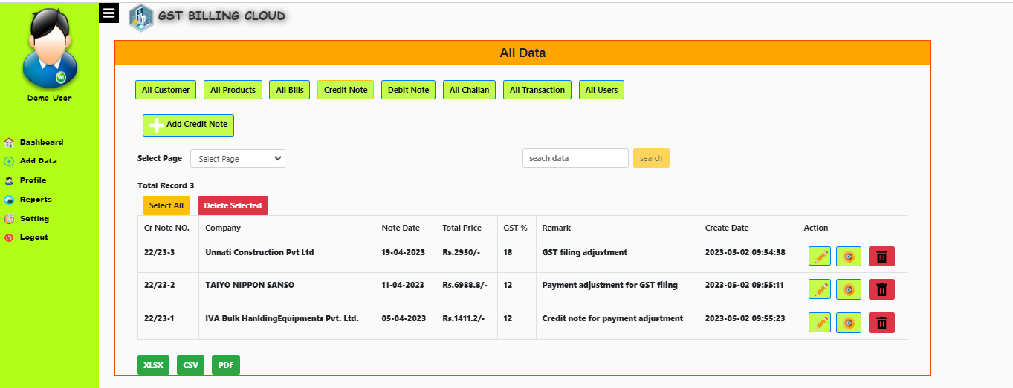
Credit Note List

Add Credit Note
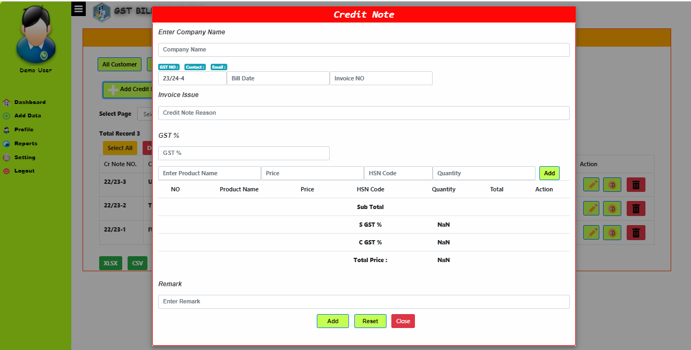

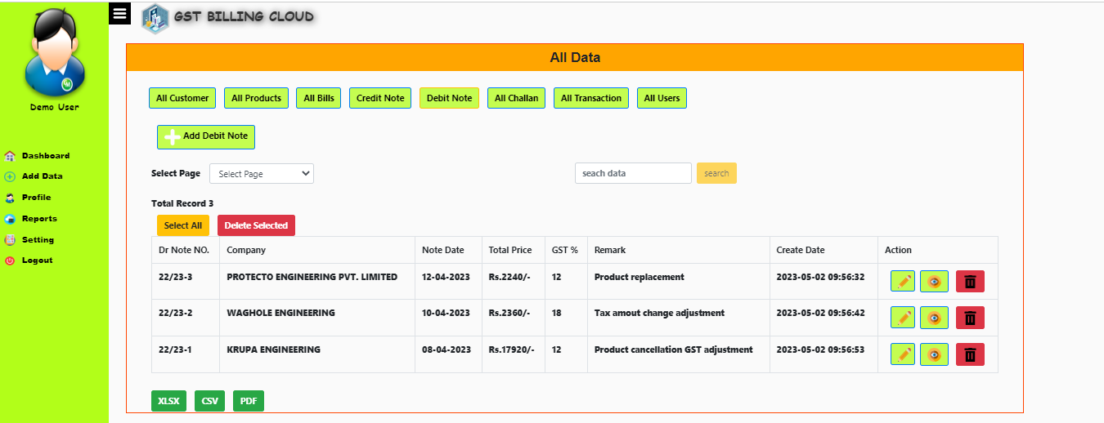
Debit Note

Add Debit Note
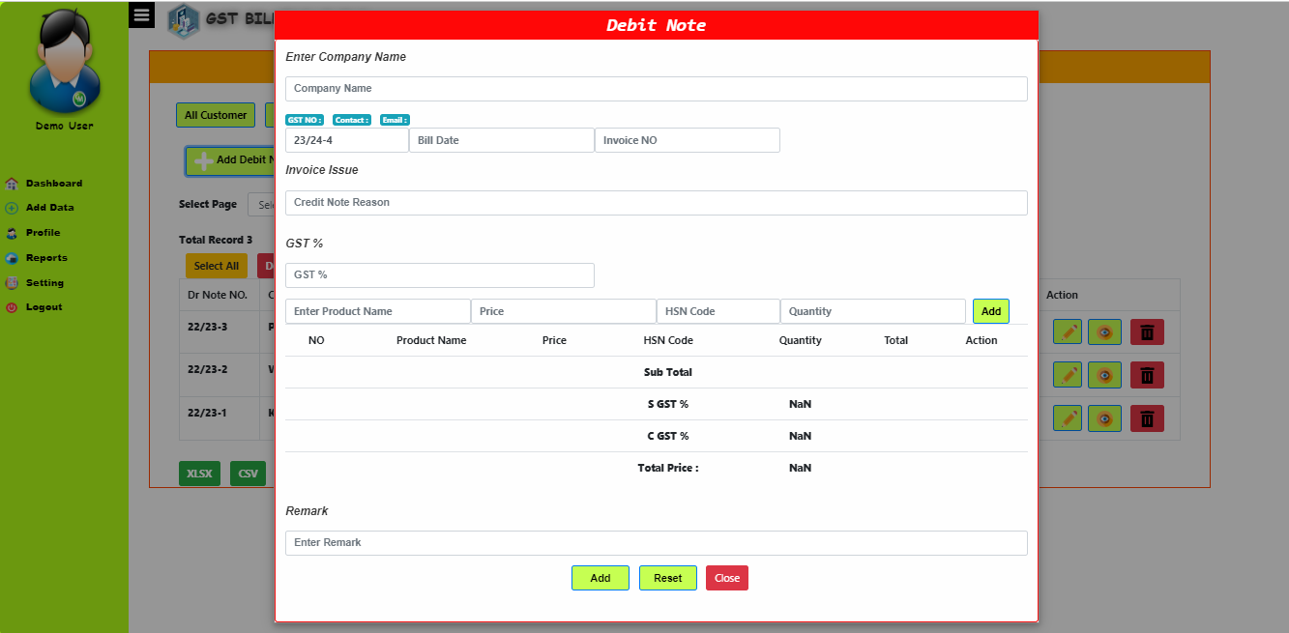

Payment Transaction
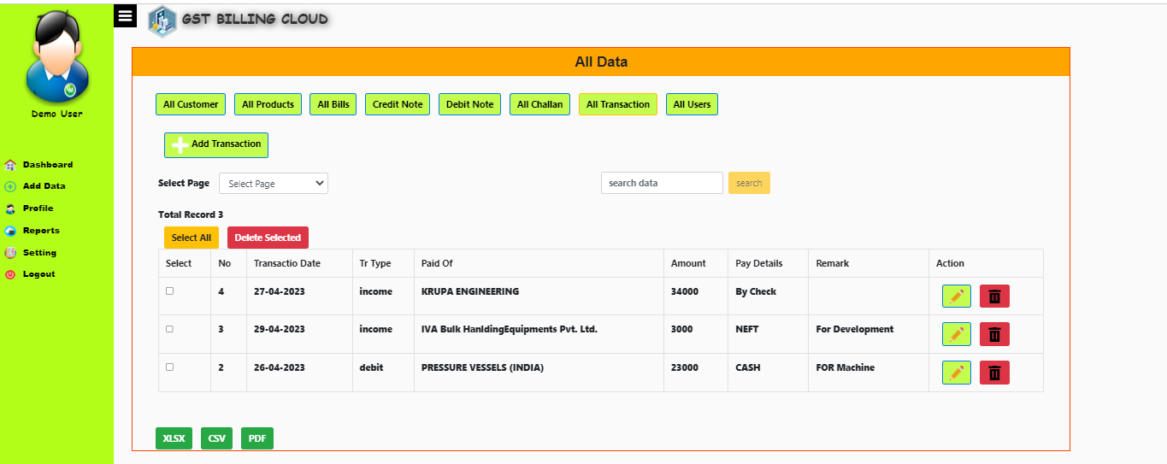

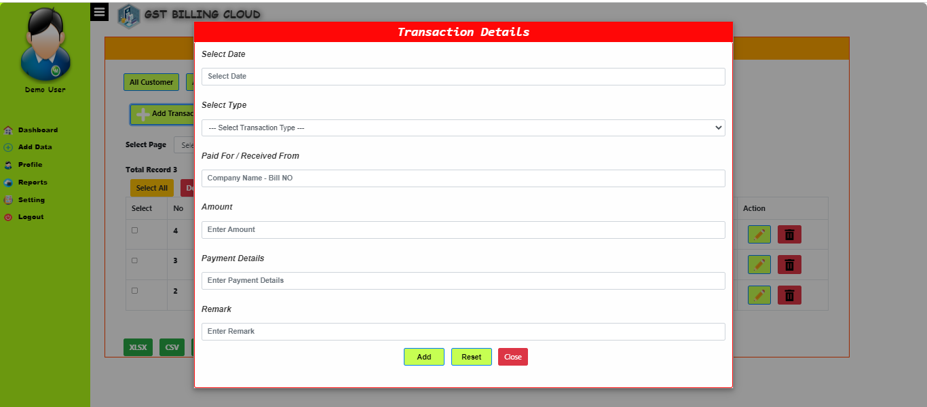
Add Transaction

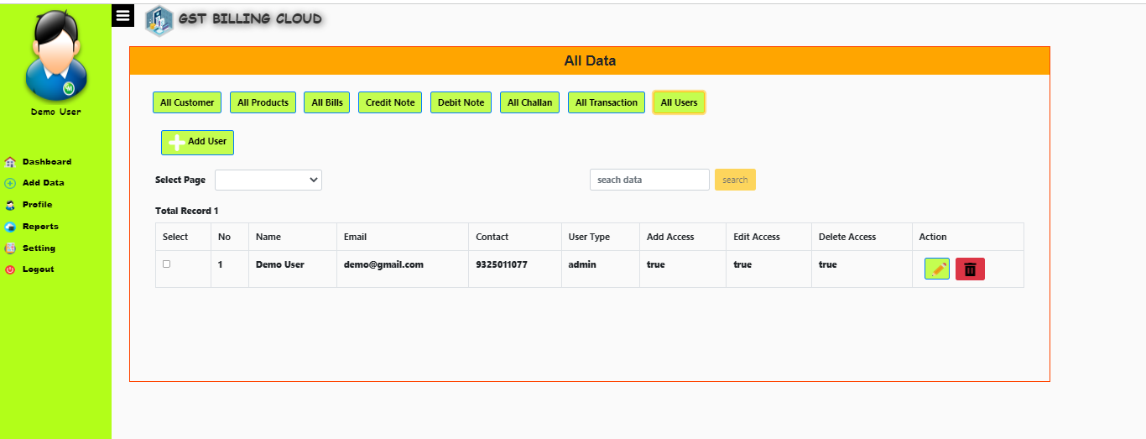
Admin list

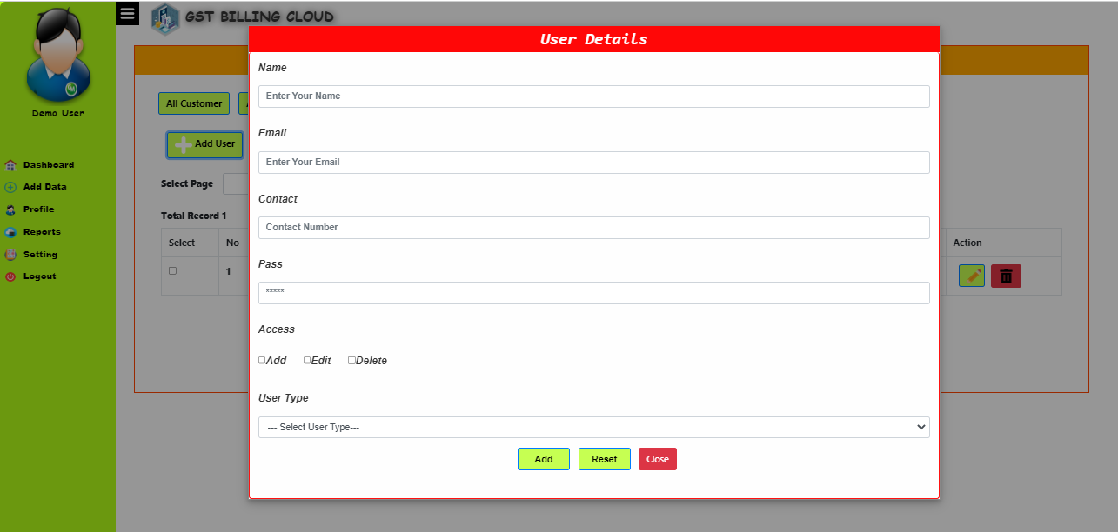
Add Admin

Month Sales
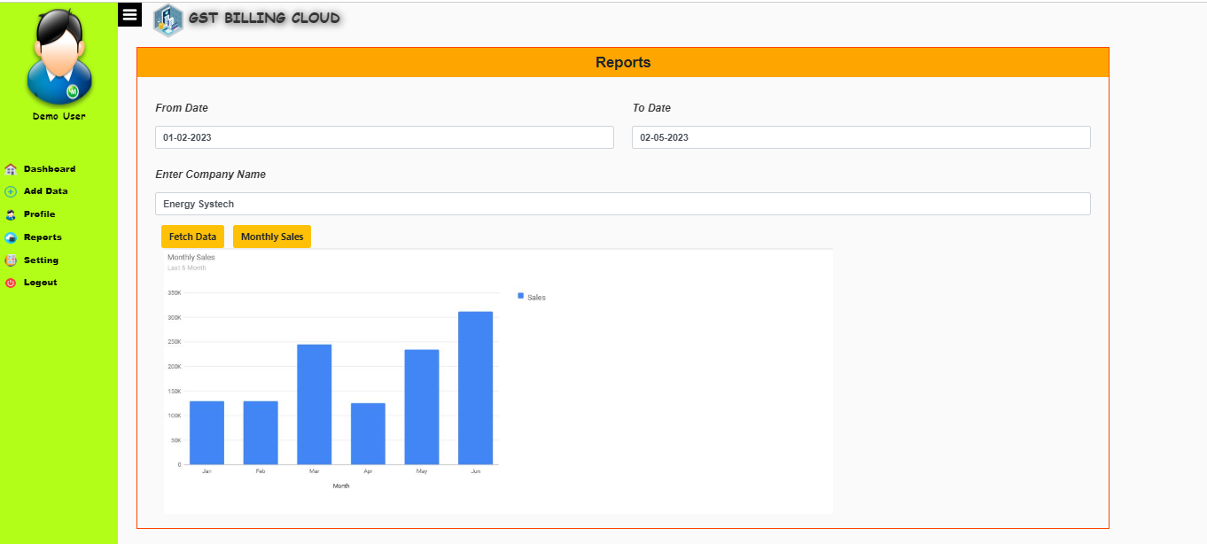

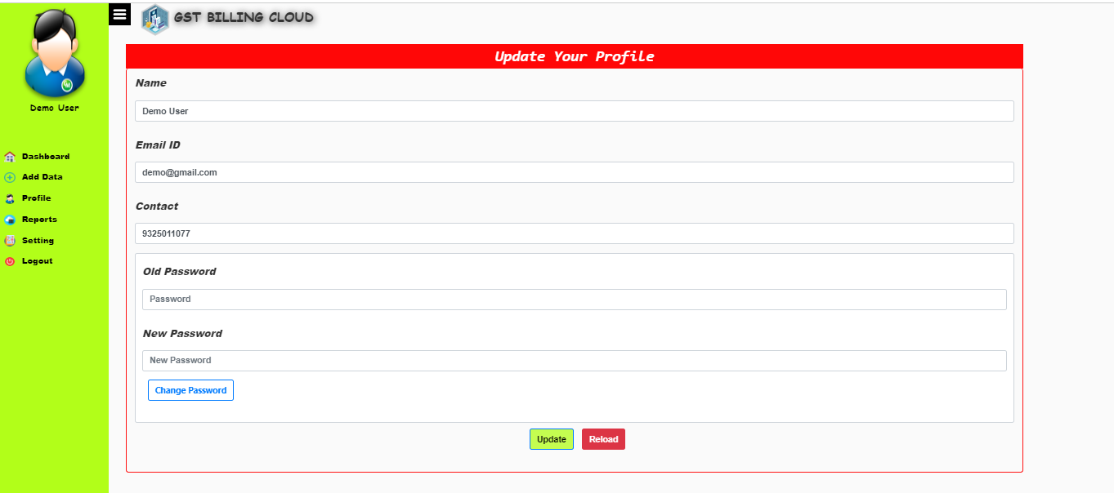
Update Profile

System Details
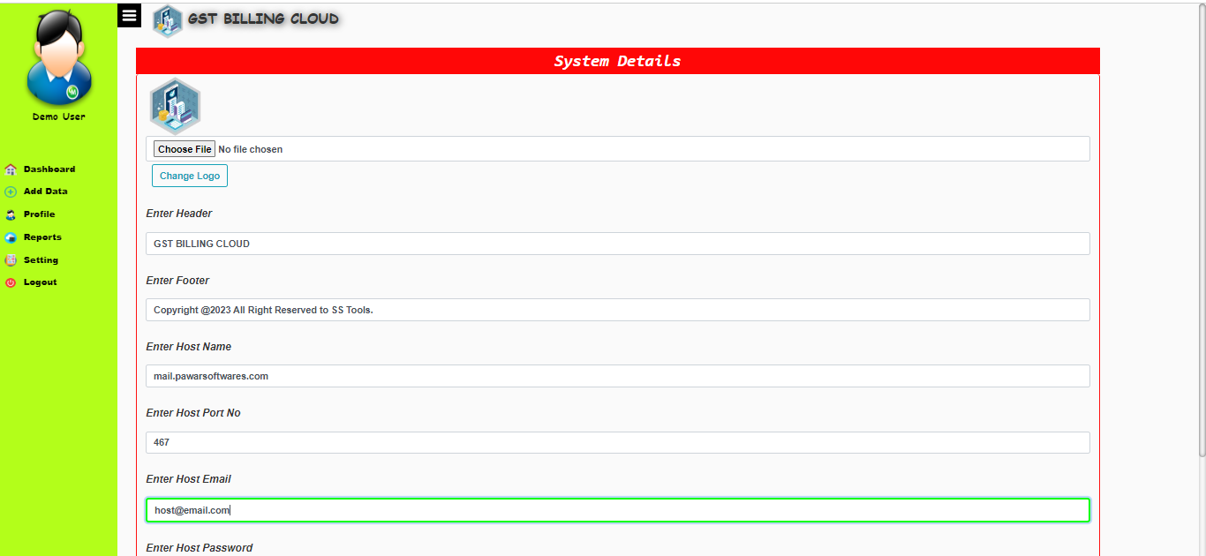

4.13 DATA DICTIONARY

- Company_details
Attribute Name | Data type and size | Constraints | Description
Cmp_id | int(11) | Primary key  (Auto Increment | Company id
logo | Varchar(100) |  | Company Logo
Bill_format | Varchar(100) |  | Bill Path
Challan_format | Varchar(100) |  | Challan Path
Cname | Varchar(100) |  | Company Name
Address | Varchar(500) |  | Company Address
Contact | Int(10) |  | Contact NO
GST NO | Varchar(500) |  | GST NO

- Customer
Attribute Name | Data type and size | Constraints | Description
cid | int(11) | Primary key  (Auto Increment | Company Id
Cname | Varchar(100) |  | Customer Name
Contact | int(11) |  | Customer Contact
Email | Varchar(50) |  | Email ID
GST | Varchar(50) |  | GST NO
Address | Varchar(500) |  | Address
Company_id | Int(10) | Forgien Key | Company Id

- Bills
Attribute Name | Data type and size | Constraints | Description
BId | int(11) | Primary key  (Auto Increment | Bill ID
Bill NO | Varchar(100) |  | Bill No
Company Id | Int | Forgien Key | Company Id
Customer_id | Int | Forgien Key | Customer id
Date | Date |  | Bill Date
Challan_data | Text |  | Customer Challan Details
Bill_Price | Int |  | Bill Total
GST_pecr | Int |  | GST %
Product_data | Text |  | Product Data
Payment_Status | Varchar(50) |  | Payment Status
Delivery_Status | Varchar(50) |  | Delivery Status
Remark | Varchar(300) |  | Remark

- Product
Attribute Name | Data type and size | Constraints | Description
Pid | int(11) | Primary key  (Auto Increment) | Product Id
Pname | Varchar(300) |  | Product Name
Hsn_code | Varchar(50) |  | Product Code
Price | Int |  | Product Price
Company Id | Int | Forgien Key | Company Id

- Challan
Attribute Name | Data type and size | Constraints | Description
Ch_id | int(11) | Primary key  (Auto Increment | Challan ID
Bill NO | Varchar(100) |  | Bill No
Company Id | Int | Forgien Key | Company Id
Customer_id | Int | Forgien Key | Customer id
Date | Date |  | Bill Date
Challan_data | Text |  | Customer Challan Details
Product_data | Text |  | Product Data
Challan Type | Varchar(50) |  | In Or out
Delivery_Status | Varchar(50) |  | Delivery Status
Remark | Varchar(300) |  | Remark

- Transaction
Attribute Name | Data type and size | Constraints | Description
Tr_id | int(11) | Primary key  (Auto Increment) | Transaction ID
Company ID | Varchar(100) | Forgien Kry | Company Id
Tr_date | Date |  | Date
Tr_type | Int(10) |  | Contact
Paid For | Varchar(50) |  | Customer Details
Paid Amount | Varchar(100) |  | User Type
Paid Details | Varchar(400) |  | Paid Details
Remark | Varchar(100) |  | Remark

Testing
Software testing is an investigation conducted to provide stakeholders with information about the quality of the product or service under test. Software testing can also provide an objective, independent view of the software to allow the business to appreciate and understand the risks of software implementation. Test techniques include, but are not limited to, the process of executing a program or application with the intent of finding software bugs (errors or other defects).
It involves the execution of a software component or system component to evaluate one or more properties of interest. In general, these properties indicate the extent to which the component or system under test:
- meets the requirements that guided its design and development,
- responds correctly to all kinds of inputs,
- performs its functions within an acceptable time, is sufficiently usable,
can be installed and run in its intended environments, and achieves the general result its stakeholder’s desire.
As the number of possible tests for even simple software components is practically infinite, all software testing uses some strategy to select tests that are feasible for the available time and resources. As a result, software testing typically (but not exclusively) attempts to execute a program or application with the intent of finding software bugs (errors or other defects).
Software testing can provide objective, independent information about the quality of software and risk of its failure to users and/or sponsors.
Software testing can be conducted as soon as executable software (even if partially complete) exists. The overall approach to software development often determines when and how testing is conducted. For example, in a phased process, most testing occurs after system requirements have been defined and then implemented in testable programs. In contrast, under an Agile approach, requirements, programming, and testing are often done concurrently
Black Box Testing
- Black-box testing focuses on the functional requirement of the software, i.e. Black- box testing enables the software engineer to derive sets of input conditions that will fully exercise all functional requirements for a program.
Black-box testing attempts to find errors in the following categories.
Incorrect or missing functions o Interface errors o Errors in data structures or external database access o Performance errors o Initialization and termination errors.

- White Box Testing
White-box testing sometimes called glass-box testing is a test case design method that uses the control structure of the procedural design to derive test cases. Using white-box testing methods, the software engineer can derive test cases that guarantee that all independent paths within a module have been exercised at least once.
Exercise all logical decisions on their true and false sides. Exercise all loops at their boundaries and within their operational bounds Exercise internal data structures to assure their validity. In this process we analyse sets of inputs needed to satisfy each and every function.

- Unit Testing
Unit testing focuses verification effort on the smallest unit of software design that is the module. Using procedural design description as a guide, important control paths are tested to uncover errors within the boundaries of the module. The unit test is normally white box testing oriented and the step can be conducted in parallel for multiple modules. In this we checked whether a specific function is doing its intended task or not.
- Validation Testing
At the end of testing software is completely assembled as a package. Validation testing is the next stage, which can be defined as successful when the software functions in the manner reasonably expected by the customer. Reasonable expectations are those defined in the software requirements specifications. Information contained in those sections form a basis for validation testing approach.
- System Testing
System testing is actually a series of different tests whose primary purpose is to fully exercise the computer-based system. Although each test has a different purpose, all work to verify that all system elements have been
properly integrated to perform allocated functions.
In this we tested weather a different software and hardware elements of a system working properly or not, such as mouse is giving right input to input module or not.

Test Cases
Test Case ID | Summary | Precondi-tion | Execution Steps | Expected Result | Actual Result | Execu-tion Status
1 | Verify that the site should be open successfully. | 1. Insert the link in URL field. | 1. Click on the search icon. | The site should be open successfully. | The site opened successfully. | Pass
2 | Verify that the site should be open quickly. | 1. Insert the link in URL field. | 1. Click on the search icon. | The site should be open quickly. | The site opened quickly. | Pass
3 | Verify that the all the text, images and input fields should be align. | 1. Execute test case ID: 1 |  | The all the text, images and input fields should be align. | The all the text, images and input fields well aligned. | Pass
4 | Verify that on login page the login fields should be center align. | 1. Execute test case ID: 1 | 1. open the site. | on login page the login fields should be center align. | on login page the login fields center aligned. | Pass
5 | Verify that the login screen contains elements such as user name, password, Login Now button. | 1. Execute test case ID: 1 | 1. open the site. | The login screen contains elements such as user name, password, Login Now button. | The login screen contains elements such as user name, password, Login Now button. | Pass
6 | Verify that the admin is able to login with valid credential. | 1. Execute test case ID: 1 | 1. type the valid adminname and password.  2.click on login button. | The admin is able to login with valid credential. | The admin login with valid credential. | Pass
7 | Verify that the admin is not able to login with invalid credential or blank fields. | 1. Execute test case ID: 1 | 1. type the valid adminname and password.  2.click on login button. | The admin is not able to login with invalid credential or blank fields. | The admin is not able to login with invalid credential or blank fields. | Pass
8 | Verify that the password is in encrypted form when enter. | 1. Execute test case ID: 1 | 1. enter in the password field. | The password is in encrypted form when enter. | The password is in encrypted form when enter. | Pass
9 | Verify that after admin login open the Home page. | 1. Execute test case ID: 6 |  | After admin login open the Home page. | After admin login open the Home page. | Pass
10 | Verify that the Home page should shows the link for all functionality available in the portal. | 1. Execute test case ID: 6 |  | The Home page should shows the link for all functionality available in the portal. | The Home page shows the link for all functionality available in the portal. | Pass
11 | Verify that the Home page should shows in well format. | 1. Execute test case ID: 6 |  | The Home page should shows in well format. | The Home page shows in well format. | Pass
12 | Verify that on billing page admin should be able to add new bill. | 1. Execute test case ID: 6 | 1. Click on Billing menu tab. | On billing page admin should be able to add new bill. | On billing page admin able to add new bill. | Pass
13 | Verify that on billing page after filling the all information of customer and items it should be shown in the list and price for every item and also total price with added GST. | 1. Execute test case ID: 12 | 1. Enter all the information of customer anf all items. | On billing page after filling the all information of customer and items it should be shown in the list and price for every item and also total price with added GST. | On billing page after filling the all information of customer and items it shown in the list and price for every item and also total price with added GST. | Pass
14 | Verify that the clicking on the save & print button it should save the all information in database and open new popup window for of billing invoice to print that bill. | 1. Execute test case ID: 13 | 1. Click on Save & Print button. | The clicking on the save & print button it should save the all information in database and open new popup window for of billing invoice to print that bill. | The clicking on the save & print button it save the all information in database and open new popup window for of billing invoice to print that bill. | Pass
15 | Verify that on purchase details page the user should able to add the purchased item in the stock databse. | 1. Execute test case ID: 6 | 1. Click on Purchase menu tab. | On purchase details page the user should able to add the purchased item in the stock databse. | On purchase details page the user able to add the purchased item in the stock databse. | Pass
16 | Verify that after filling all information of item purchased it should be succesfully added in stock. | 1. Execute test case ID: 15 | 1. Enter all the information.  2.click on Save button. | After filling all information of item purchased it should be succesfully added in stock. | After filling all information of item purchased it succesfully added in stock. | Pass
17 | Verify that on customer page it should shows the list of all customer those are added previously. | 1. Execute test case ID: 6 | 1. Click on Customer menu tab. | On customer page it should shows the list of all customer those are added previously. | On customer page it shows the list of all customer those are added previously. | Pass
18 | Verify that after filling all the information of add new customer it should be added into the database. | 1. Execute test case ID: 17 | 1. Enter all information in fields of add new cutomer.  2.click on Add Customer button. | After filling all the information of add new customer it should be added into the database. | After filling all the information of add new customer it added into the database. | Pass
19 | Verify that after adding new customer successfully it should be shows in the customer list. | 1. Execute test case ID: 18 | 1. Click on Refresh Table button. | After adding new customer successfully it should be shows in the customer list. | After adding new customer successfully it shows in the customer list. | Pass
20 | Verify that the clicking on edit customer button we should able to edit the information of any customer. | 1. Execute test case ID: 17 | 1. Click on Edit Customer button. | The clicking on edit customer button we should able to edit the information of any customer. | The clicking on edit customer button we able to edit the information of any customer. | Pass
21 | Verify that the clicking on delete customer button we should able to delete the customer from the list. | 1. Execute test case ID: 17 | 1. Click on Delete Customer button. | The clicking on delete customer button we should able to delete the customer from the list. | The clicking on delete customer button we able to delete the customer from the list. | Pass
22 | Verify that on items page it should shows the list of all item those are added previously with the SGST and CGST. | 1. Execute test case ID: 6 | 1. Click on Items menu tab. | On items page it should shows the list of all items those are added previously with the SGST and CGST. | On items page it shows the list of all items those are added previously with the SGST and CGST. | Pass
23 | Verify that after filling all the information of add new item it should be added into the database. | 1. Execute test case ID: 22 | 1. Enter all information in fields of add new item.  2.click on Add new item button. | After filling all the information of add new item it should be added into the database. | After filling all the information of add new item it added into the database. | Pass
24 | Verify that after adding new item successfully it should be shows in the items list. | 1. Execute test case ID: 23 | 1. Click on Refresh button. | After adding new item successfully it should be shows in the items list. | After adding new item successfully it shows in the items list. | Pass
25 | Verify that on Dealer page it should shows the list of all Dealer those are added previously. | 1. Execute test case ID: 6 | 1. Click on Dealer menu tab. | On Dealer page it should shows the list of all Dealer those are added previously. | On Dealer page it shows the list of all Dealer those are added previously. | Pass
26 | Verify that after filling all the information of add new Dealer it should be added into the database. | 1. Execute test case ID: 25 | 1. Enter all information in fields of add new cutomer.  2.click on Add Dealer button. | After filling all the information of add new Dealer it should be added into the database. | After filling all the information of add new Dealer it added into the database. | Pass
27 | Verify that after adding new Dealer successfully it should be shows in the Dealer list. | 1. Execute test case ID: 26 | 1. Click on Refresh Table button. | After adding new Dealer successfully it should be shows in the Dealer list. | After adding new Dealer successfully it shows in the Dealer list. | Pass
28 | Verify that on reports page it should shows the all the selled items list with the customer details. | 1. Execute test case ID: 6 | 1. Click on Reports menu tab. | On reports page it should shows the all the selled items list with the customer details. | On reports page it shows the all the selled items list with the customer details. | Pass
29 | Verify that after entering the the date in search box the it should shows the all selled items in between that date. | 1. Execute test case ID: 28 | 1. Enter the date in the search box.  2.click on Search button. | After entering the the date in search box the it should shows the all selled items in between that date. | After entering the the date in search box the it shows the all selled items in between that date. | Pass
30 | Verify that on company details page user should be able to update the company details. | 1. Execute test case ID: 6 | 1. Click on Company Details menu tab. | On company details page user should be able to update the company details. | On company details page user able to update the company details. | Pass
31 | Verify that the after click on the logout button it should logout and clear all cookies. | 1. Execute test case ID: 7 | 1. click on the 'Logout' button. | After click on the logout button it should logout and clear all cookies. | After click on the logout button it logout and clear all cookies. | Pass

User Manual
Step 1: Open Link In Browser.
Step 2. Fill Login Details And click sign in it will redirect to dashboard. In case of forget password click on forget pass on login screen. Enter email id and click submit one OTP will sent on that mail. Enter the OTP then proceed to enter new password & click on submit.
Step 3. After Successful Login Dashboard will show the short reports about your data. After that It will show current active company database. In case of change company database select company from drop down and click on active button. And Below One more option is to add new company or update previous company details.
Step 4. Then Next Step to add data. Click on add data menu on left side. I will show various tab on screen. In order to add customer click on customer tab I will show all available customer. Then click on add customer to get form. Fill the all details and click on save. Repeat the same process for product ,transaction.
Step 5. In Order to create Bills and challan Click on Add Bills button in All Bills Tab. It will open Bill Form To add Customer details just enter first two digit of customer name it will make list of customer according to match. Same process to add product in bills or challan.
Step 6. To download bill simple click on eye button to get bill in excel format. Also it has functionality to generate data in pdf or xls Xlsx.
Step 7. To update Admin Profile Click On Profile to update profile. Ther you can change password also.
Step 8.To Update Application Details You Can Click Setting tab to change header and footer. And other system details. Like Host Mail, Host Port No. Website Location Etc.
Step9. Refer above screenshot for more details.

Drawbacks and Limitations

- Internet Connectivity: As the system is hosted on the cloud, it is completely dependent on internet connectivity. If the internet connection is lost, the user cannot access the system and perform any task.
- Security concerns: Storing sensitive data on the cloud raises security concerns, as it is susceptible to cyber attacks and data breaches. It is important to implement robust security measures to protect the data from unauthorized access.
- Limited control: The user has limited control over the system as it is managed by the cloud service provider. Any updates or maintenance tasks are performed by the provider, which can lead to downtime and affect the user's operations.
- Dependence on service provider: The user is completely dependent on the cloud service provider for the system's performance, uptime, and reliability. Any issues faced by the provider can affect the user's operations, and it can take time to resolve them.
- Integration issues: Integrating the cloud GST billing system with other systems and software can be challenging. The user must ensure that the system is compatible with other systems and can seamlessly integrate with them.

Proposed Enhancements
- Integration with multiple payment gateways to facilitate easy and secure payments for customers.
- Mobile application for customers to access their invoices, bills and make payments on-the-go.
- Integration with accounting software to automatically transfer invoices and transaction data to the accounting system.
- Advanced reporting and analytics capabilities to provide insights into sales trends, inventory levels, and customer behavior.
- Integration with shipping and logistics providers to provide real-time shipping rates and tracking information to customers.
- Integration with e-commerce platforms to allow merchants to sell their products directly through the billing system.
- Multilingual support to cater to customers from different regions who speak different languages.
- Automated reminder system for payment due dates, payment confirmations, and other notifications.
- Advanced security features such as two-factor authentication and encryption of sensitive data.
- Integration with other tax compliance software to streamline tax filing and reporting requirements.

Conclusion

In conclusion, the cloud GST billing system is a powerful tool that can streamline the billing process for businesses of all sizes. It provides a range of capabilities such as managing customers, transactions, debit notes, credit notes, users, challan, products, bills/invoices, reports, and settings. The system has functional and non-functional requirements that must be met to ensure it runs smoothly. There are also assumptions and dependencies that must be considered before implementing the system. While the system has some drawbacks and limitations, proposed enhancements can address these issues and improve its overall performance. Overall, the cloud GST billing system can greatly benefit businesses by simplifying and automating their billing processes.

Bibliography
Before, during and after the development of the computerized system we refer some books which guide me for program development, coding, drawing graphic representation etc. List of such books is specified below:

Reference books:-

- Learning PHP, MySQL, JavaScript and CSS:A step-by-Step Guide to creating Dynamic Website –By Robin Nixon
- PHP:A Beginner’s Guide –By VikramVaswani

Web Site:-

- www.W3school.com
- www.php.net
- https://Stackoverflow.com

